|  |  |
| --- | --- |
| Team Id Project Hazardous Area Monitoring for Industrial Plant powered by IOT | PNT2022TMID44638 |
| Name | Project Hazardous Area Monitoring for Industrial Plant powered by IOT |

Design Your UI To Display The Temperature, Humidity

Design your UI to display the Temperature, Humidity sensor values. UI Dashboard

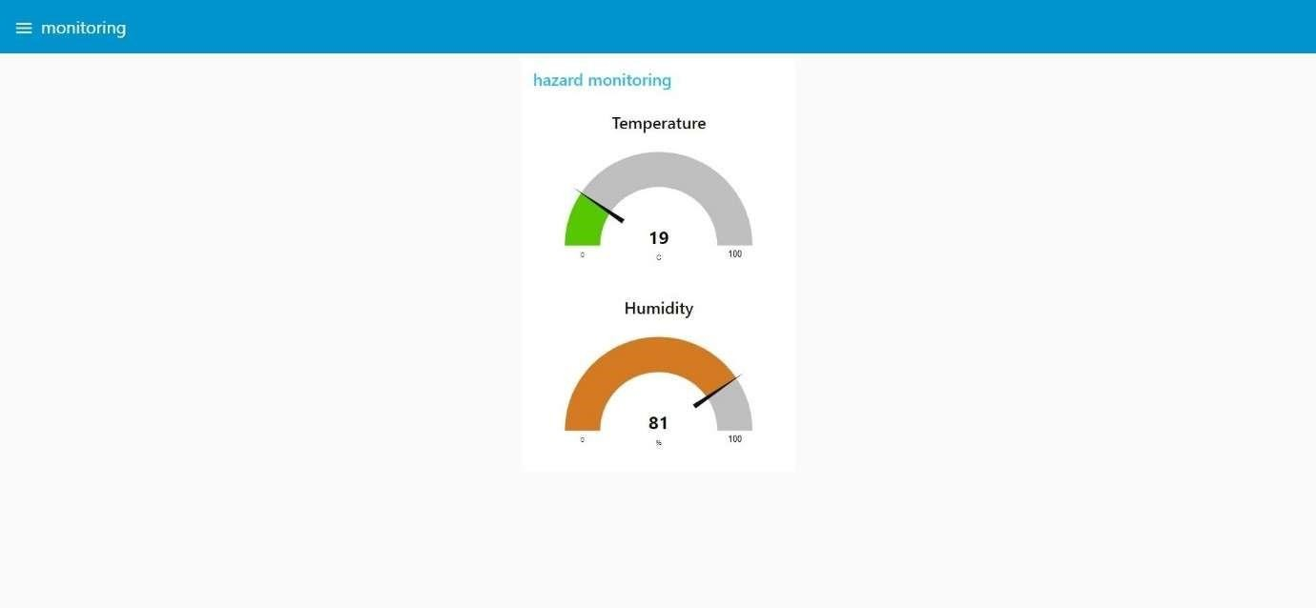

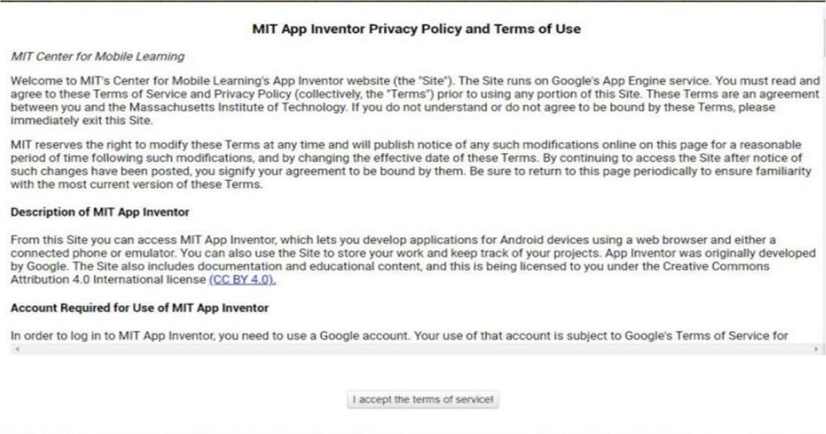

. About Educators News Resources Blo gs



a52 BK

